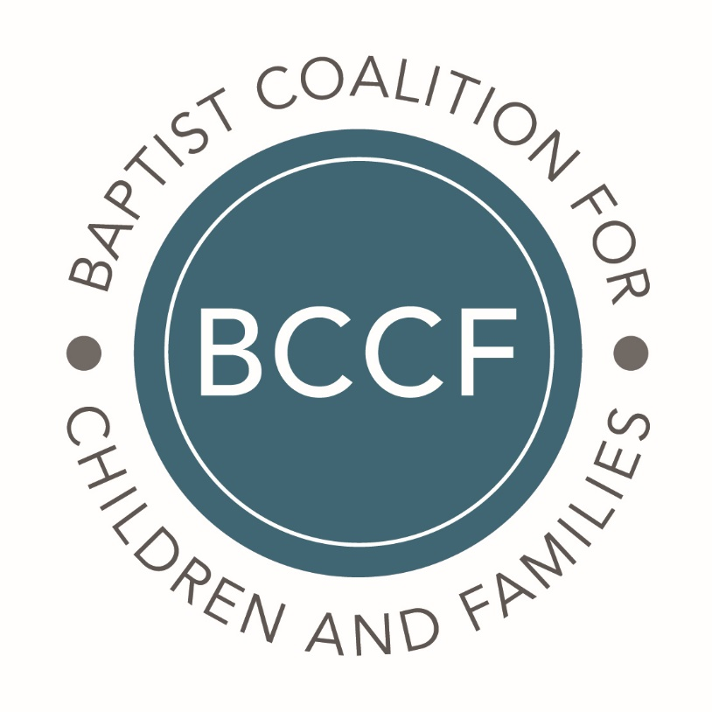

2019 Annual Report

Submitted April 30, 2020
Jill Roberson, Historian

ALABAMA
Alabama Baptist Children's Homes & Family Ministries
Rod Marshall
President/CEO
2012
- We completely renovated our administrative building and named it the Paul and Diane Miller Administrative Service Center. This renovation nearly doubled the size of our training room, allowing us to train more foster families.
- We built a new 8,000 square feet counseling center attached to our administrative center in Birmingham which has 16 offices and 6 play therapy rooms, each with an observation room.
- We had record attendance at our annual Camp of Champions, with 1,134 in attendance.
- We had 39 adoptions and 199 reunifications with biological relatives
- We raised $617,210 in our annual Giving Tuesday campaign (up from $408,670 in 2018!)
- We bought a new building for our Dothan area ministries with over double the square footage in response to significant growth in our foster care ministry in Dothan.
- We began (and nearly completed) two new homes on our Decatur Campus, one being a multi-purpose duplex and the other being a new shelter care home.

ALASKA
Birchwood Behavioral Health

Sarah Cambridge

Executive Director
2019

- Executive Director David Banks left Birchwood in October 2019 and the Executive board asked Sarah Cambridge to become the Interim Director.

- Our outpatient program has reached over 40 members in the community and there is currently a waitlist. Two additional outpatient clinicians have been hired to fill the mental health needs in the community.

- Our residential program has been able to support over 20 youth and families. Youth and families work together with the Birchwood staff to build healthy relationships.

ARIZONA
Arizona Baptist Children's Services
Steve Hanna
President/Executive Director
2009
- Central Phoenix Community Church closed its doors and donated the property to ABCS in January. ABCS had been renting the education building since 2016. This property establishes a long-term home for the Phoenix office.
- The Bridge Church and ABCS have been co-located at the Rio Vista and Casa de Amor resource centers and have formalized their partnership to start a new church plant at the Phoenix office in 2020.
- ABCS launched plans for a home and program for young women aging out of foster care. ABCS already owned the property and $100,000 in gifts, new appliances and services was donated to remodel the 4-bdr home. The home opens in January 2020.
- ABCS hosted 250 guests in April at the Spring Fling in Phoenix. It was the first banquet fundraiser for ABCS in over 20 years and was great fellowship with donors, ministry partners and foster families.
- The Caring Ministries resource center started a Life Development program to help adults make healthy choices. Two men graduated in December and are now working in resource center leadership.
- ABCS moved its Eastern Region office to First Baptist Church Show Low. ABCS’ first ministries in eastern AZ began 20 years ago in Show Low before relocating to Snowflake, AZ.
- State foster care contracts were renewed in the summer, resulting in the first rate increase in 14 years. The new contract allowed us to expand our foster care services into four new counties. ABCS is now licensing foster families in 11 of 15 Arizona counties.

ARKANSAS
Arkansas Baptist Children's Homes and Family Ministries
Derek Brown
Executive Director
2018
1. Celebrated 125 years of ministry
2. Launched a standard of care program to promote trauma-informed, family focused, and Christ-centered values
3. Built John Ross Ministry Center at Arkansas Baptist Ranch
4 .Built Family Counseling Center in Little Rock in honor of David Perry
5. Became the largest private foster care provider in Arkansas
6. Began campus renovation at the Arkansas Baptist Home for Children
7. Branded the counseling ministry as Living Well Counseling
8. Started the transition from family-style residential care to campus foster care, prioritizing large sibling groups (completed transition early 2020)

Florida
Florida Baptist Children’s Home and One More Child
Dr. Jerry Haag
President/CEO
2007 - 2011, 2012 – Present
1. Last year, FBCH and One More Child impacted 261,691 children and individuals in the loving and life-changing name of Christ!
2. We were able to provide more than 10 million meals to children and individuals in need. By meeting the tangible need of food for hungry children, hundreds of thousands were introduced to God’s love and his steadfast Word.
3. Also in 2019, 1,691 children were placed in loving, Christian foster homes, and 89 children were adopted into forever families.
4. We collected 826,439 diapers during our 2019 annual diaper drive! These diapers will be used by foster families, single moms and, children in the Malnutrition Center in Guatemala and more.
5. More than 3,577 individuals were impacted through advocacy, training and awareness through our Sanctity of Human Life program.
6. Through our Family Support services, we worked closely with DCF to prevent future crises in families. We provided food, diapers, and clothing, and we also led life-skills workshops.
7. Over the past year, our leadership and expertise in Anti-Trafficking reached new heights for vulnerable children and trafficking survivors. In addition to impacting 319 victims of sex trafficking, 18,638 individuals were impacted through education, advocacy and awareness.
Georgia
Georgia Baptist Children's Homes and Family Ministries, Inc.
Kenneth Z. Thompson
President/CEO
2016
1. Continued expansion of the Communications and Development department
2. Received certification in the Sanctuary Model of Care
3. Began the process for reaccreditation with Council On Accreditation (COA)
4. Expanded the number of teachers and educational opportunities through the Arwood Malcom Education Center
5. Restructured the human resources department to include hr, payroll, recruiting and training
6. Added additional respite weekends for children with developmental disabilities
7. Rebranded our foster care program to Bright Family Foster Care

ILLINOIS
Illinois Baptist Children's Home & Family Services
Denny Hydrick
Executive Director
2016
Board approved a new program - Crisis Pregnancy Medical Clinic

KENTUCKY
Sunrise Children's Services, Inc.
Dale Suttles
President
Since 2013
- Celebrated 150th anniversary of the organization
- Celebrated 62 adoptions for a total of 500 since the beginning of foster-to-adopt in 2010
- Provided 151,424 days of care to 2,081 unduplicated clients
- Performed 21,692 services through Family Services to 1,238 individuals
- Provided 10,248 days of care to 53 Independent Living clients

LOUISIANA
Louisiana Baptist Children’s Home & Family Ministries
Perry Hancock
President & CEO
2003
- Completed 2nd new Family Care cottage for homeless children and their mothers. A 3rd FC cottage will be completed by 2021.
- Expanded Foster Care services. Added one additional social worker in Northwest Louisiana. Established a new ministry for children who are victims of human trafficking.
- Expanded Compassion for Kids in Northwest Louisiana. Providing life essentials for children and families in need through partnership with local churches.
- Opened the new Children’s Village in Haiti. The facilities house at risk children who are economic orphans. The facility includes a day school for all children in the area.

MISSOURI
Missouri Baptist Children's Home
Russell Martin
President
2014
- Opening of home for human trafficking rescue for minors in the
Kansas City area (makes third home statewide)
2. Trained 1,705 people in sexual abuse awareness during 2019
3. Maintained 303 licensed foster/adoptive and relative homes of
12/31/2019
4. Provided training for foster parents at family camps in Moldova
and Ukraine
- Facilitated 187 children reaching permanency (76 reunifications,
24 guardianships, and 87 adoptions)

NORTH CAROLINA
Baptist Children's Homes of North Carolina
Michael C. Blackwell
President/CEO
1983
- Family Foster Care is quickly growing. BCH provides the training and support needed for a family’s home to become licensed. Several churches are partnering with BCH to begin their own foster care ministries. BCH’s vision is to grow its number of family foster homes to 100 in each of the state's 100 counties by the end of 2020.
- BCH and Christian Adoption Services have partnered to offer comprehensive foster care and adoption services to families. BCH provides foster care expertise while CAS facilitates the adoption process.
- BCH’s podcast “It’s a family matter.” with BCH president/CEO Michael C. Blackwell launched in August, 2019. In the new podcast, Blackwell interviews a wide variety of guests from former BCH residents to personalities such as Dr. Gary Chapman.
- BCH opened new facilities including the Ammons Education Center at Cameron Boys Camp in Moore County. Westmoreland Family Children’s Home in Guatemala opened to become a home to seven orphans. It is a complement to BCH’s affiliate, Good Shepherd Children’s Home.
- BCH cottage parents Betty and Will Porter received the prestigious Catherine Hershey Houseparent of the Year Award at the annual Coalition on Residential Excellence (CORE) Conference in Little Rock, Arkansas. The Porters have served at BCH’s Broyhill Home in Clyde, NC for 31 years.
- In 2018, the Greater Vision Outreach Ministry impacted 71,946 lives. Greater Vision, based at Mills Home in Thomasville, NC, is adding a new location at Kennedy Home in Kinston, NC

NEW MEXICO
New Mexico Baptist Children's Home and family Ministries
Randy Rankin
President/CEO
2010
- Opened satellite campus in Alamogordo' New Mexico
- Near completion of new campus in Estancia ,New Mexico
- Constructed a new chapel on Main campus in celebration of 100th Anniversary
- Hired worker and began Adoption Ministry

OKLAHOMA
Oklahoma Baptist Homes for Children
Greg McNeece
President
2015
- Saw 100 people to accept Christ as Savior
- Served 240 children in traditional residential care
- 10 mothers received some type of education achievement certification
- 60 students participated in a leadership conference learning leadership characteristics
- Placed an order for a custom mobile pregnancy center
- Campus leadership changes with long term administrator retirement of a twenty plus year leader
- Took 16 students in care with additional donors to Washington D.C. to visit our nation’s capital.

SOUTH CAROLINA
Connie Maxwell Children’s Home
Danny Nicholson
President
2017
- Creation of Strategic Plan
- New Branding Initiative
- Hire new VP for Human Resources and development of HR Office
- Reconstruction of Advancement and Finance software and systems
- Connie Maxwell Christmas had over 18,000 people visit campus over a three day period
- Initiation of Campus Master Plan
- Collaboration with SC Baptist Convention to market and promote Foster Care on a higher level

TENNESSEE
Tennessee Baptist Children's Homes, Inc.
Greg McCoy
President/Treasurer
2016
- Successfully completed re-accreditation with COA
- Hired Accreditation and Training Specialist to oversee all accreditation requirements
- Introduced all staff to "Stewards of Children" produced by Darkness to Light
- Five staff members trained to train others in "Stewards of Children"

TEXAS
Buckner International-Buckner Children and Family Services, Inc.
Albert L. Reyes
President and CEO
2007
1. Foster Care = 1,210 Placements (domestic and international)
2. Adoptions = 170 (US and Kenya)
3. Family Pathways = 199 Families/ 354 children
4. Family Hope Centers = 21,500 individuals domestically
5. Family Hope Centers = 45,500 individuals internationally
6. Camp Buckner = over 18,000 individuals
7. Formal Schools = over 1,900 children (Kenya)
8. Total Served = 147,845

Children At Heart Ministries
Todd Roberson
President and CEO
2011
1. Had 3 or 4 employees with very severe health issues in 2019. One was the President of one of our organizations, and he spent the majority of the year in the hospital. Our staff, clients, donors, friends, and many of you prayed for these individuals by name during much of 2019. God's miraculous hand was very evident in each situation, and we give thanks for the healing that occurred in the life of each one!
2. Completed four new duplexes for the Next Step program at Gracewood in Houston. All four duplexes (8 units) are full and serving the families on the Gracewood campus.
3. Reinstituted the position of Vice President for Mission Advancement at the Children At Heart Ministries level, and welcomed Maynard Phillips into that "new again" role. Maynard is doing a great job of leading our people raising, fundraising, development work and the teams that go with it for all of our organizations.
4. Miracle Farm served 21 young men in 2019; 12 made professions of faith in Christ!
5. STARRY saw 31 children adopted into forever families in 2019.
6. Texas Baptist Children's Home saw 33 children or single mothers make professions of faith in Christ or rededicate their lives to Christ.
7.STARRY trained 769 community leaders in Trauma Informed Care.

South Texas Childrens Home Ministries
Eron Green
President and CEO
2012
- Implemented 24-hour awake staff program for PMC children as mandated by State of Texas
- Focused on growing into our budget
- 2019 was an intentional year of refinement for all programs

